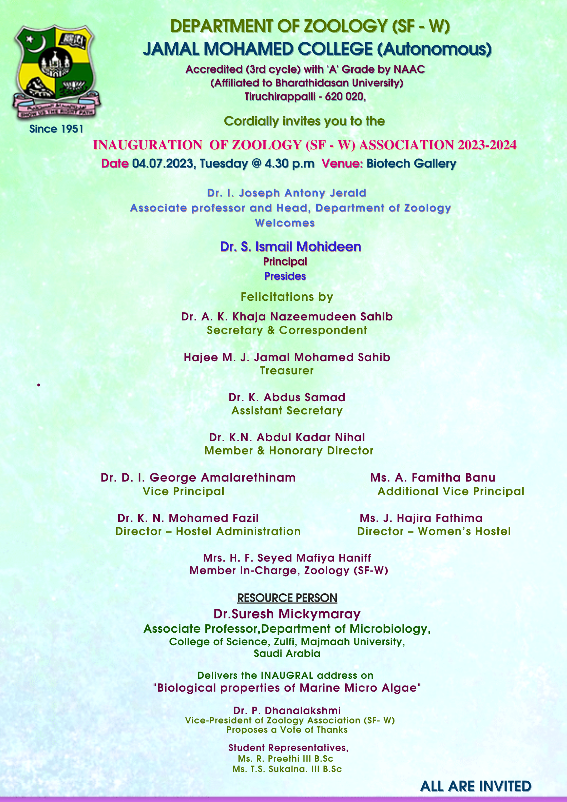
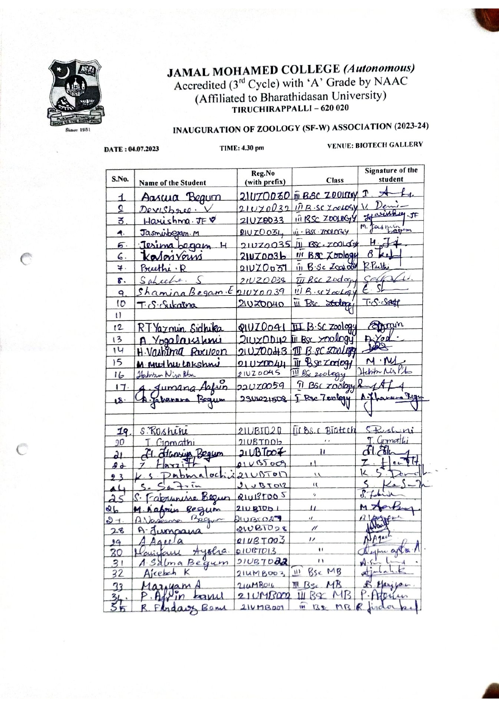
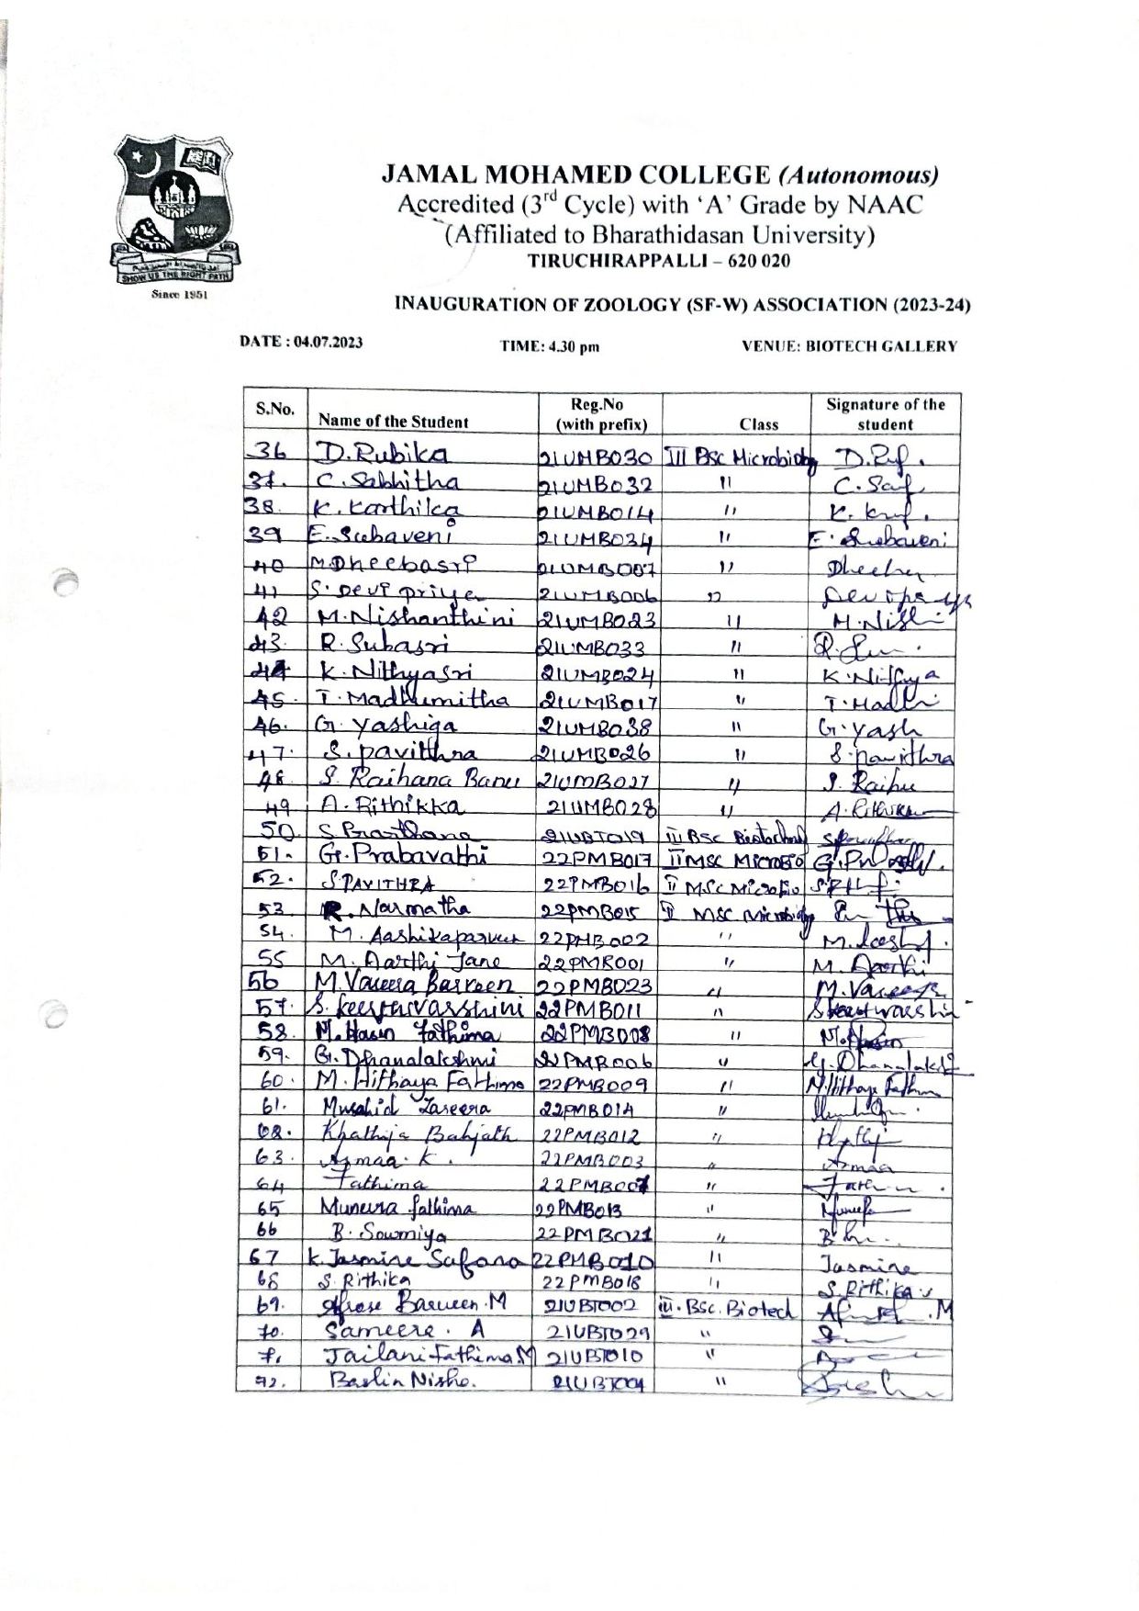
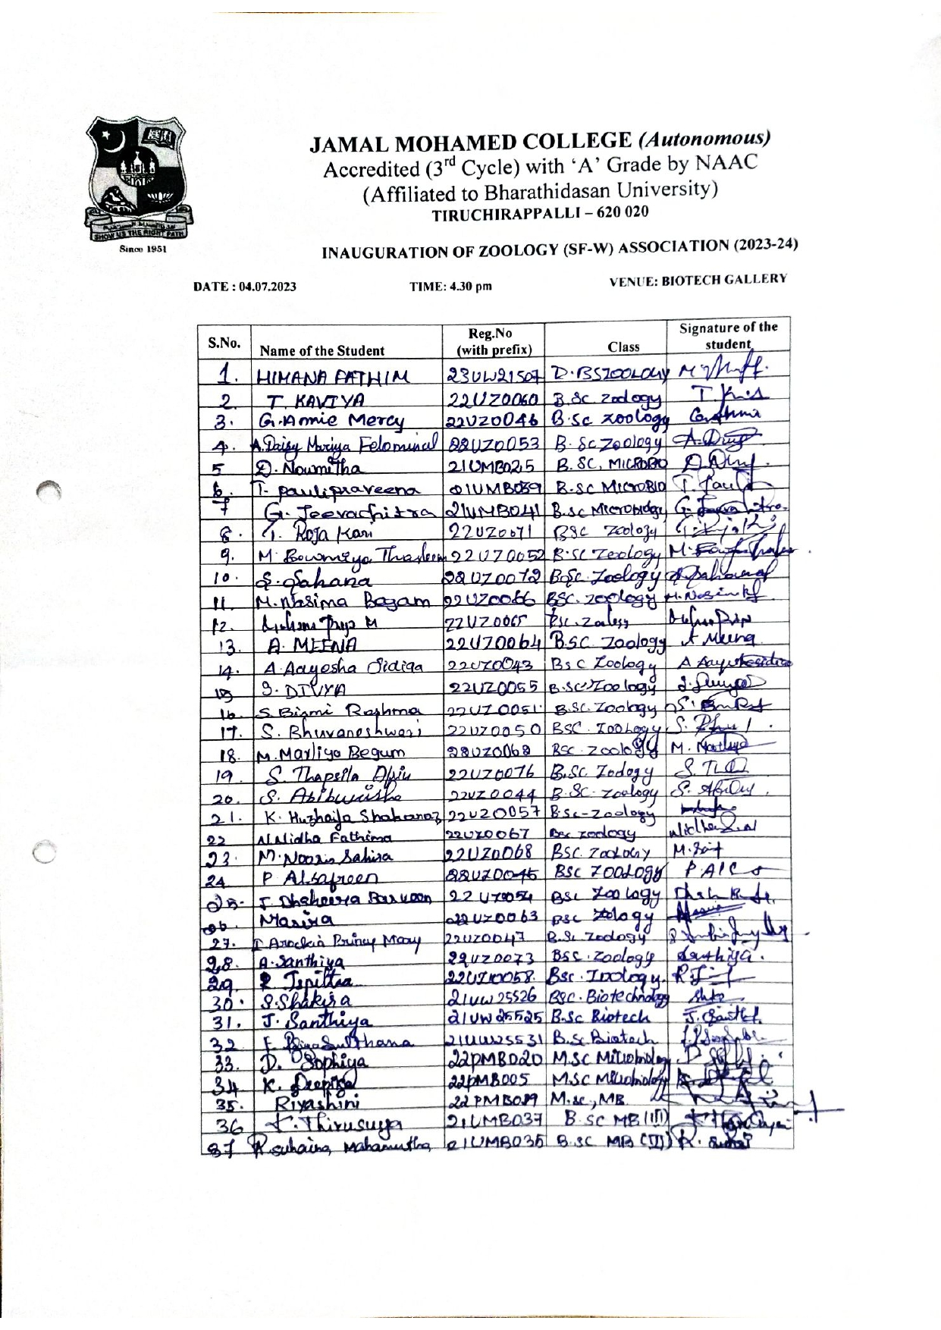
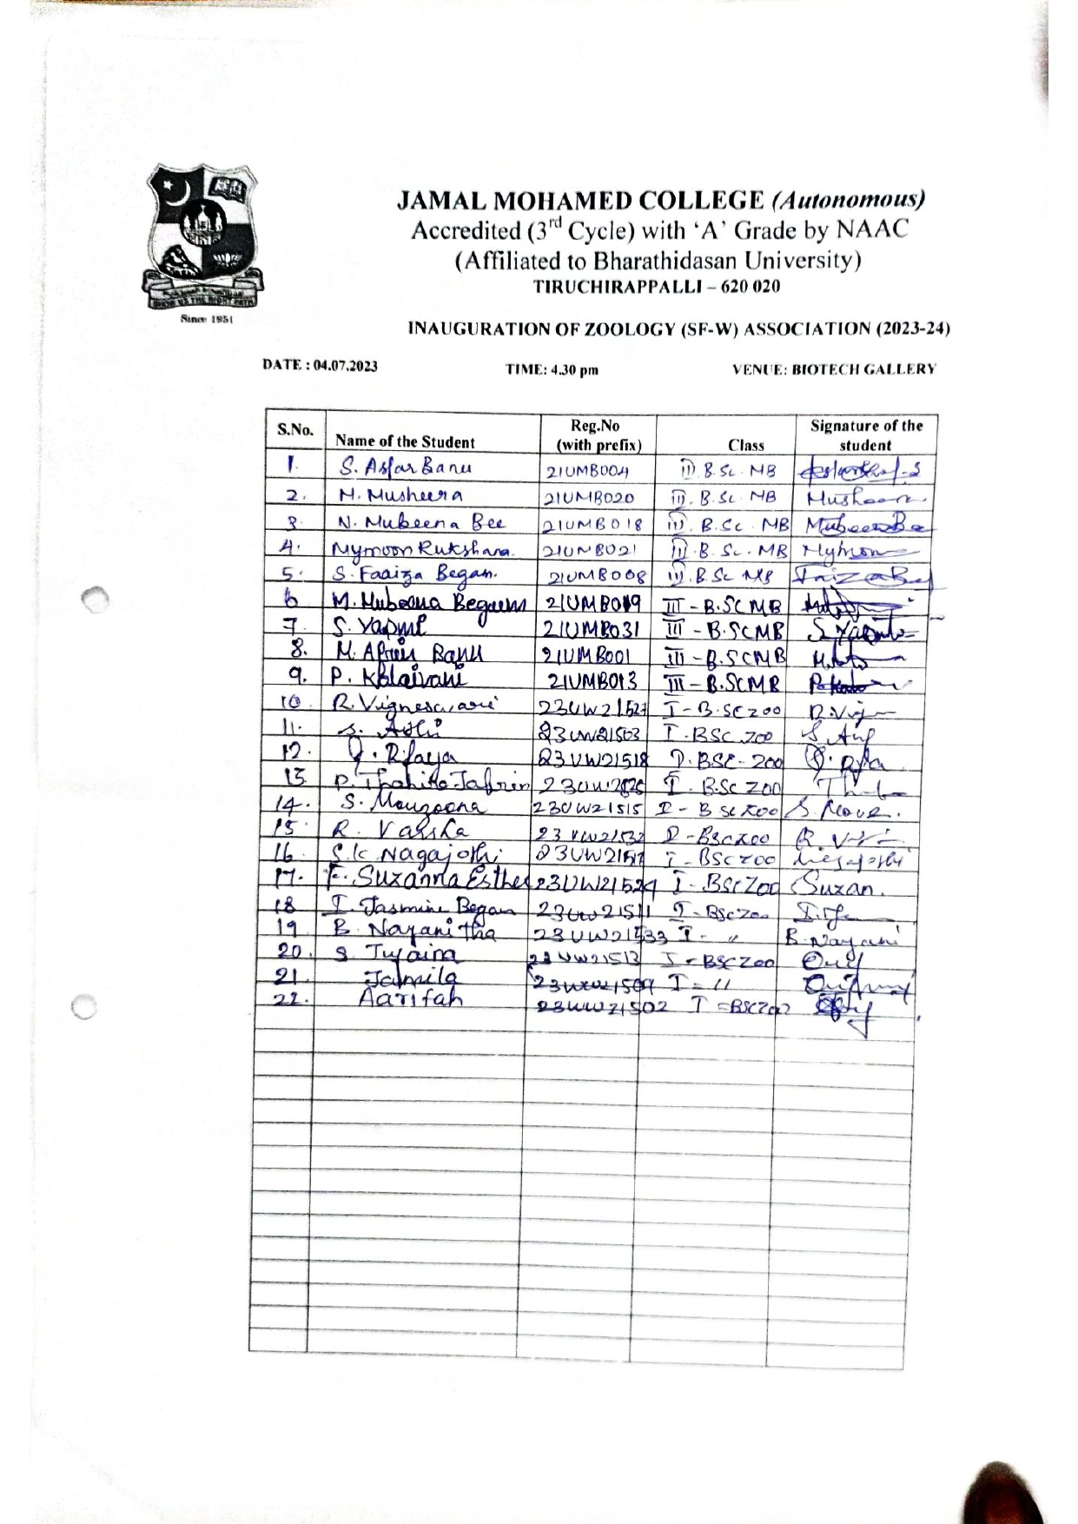
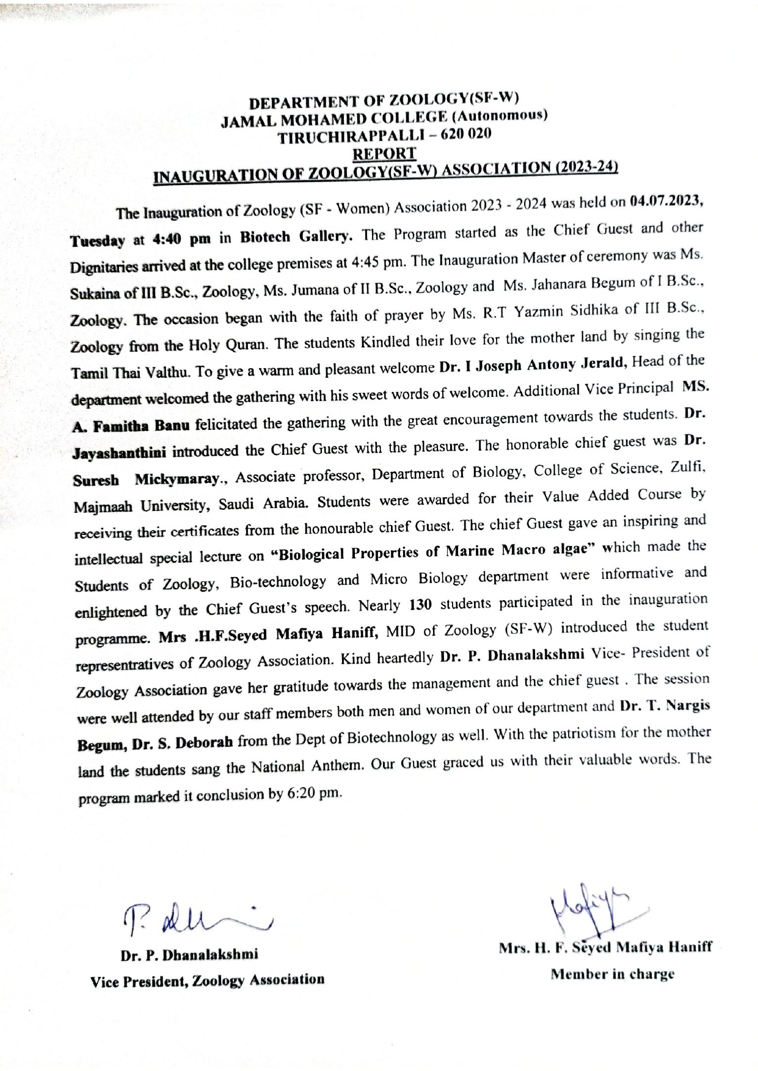

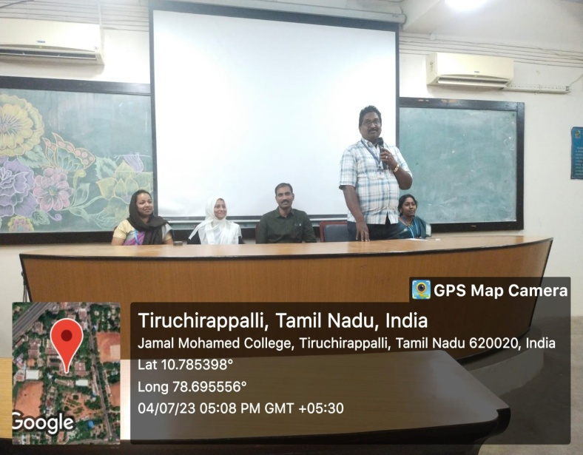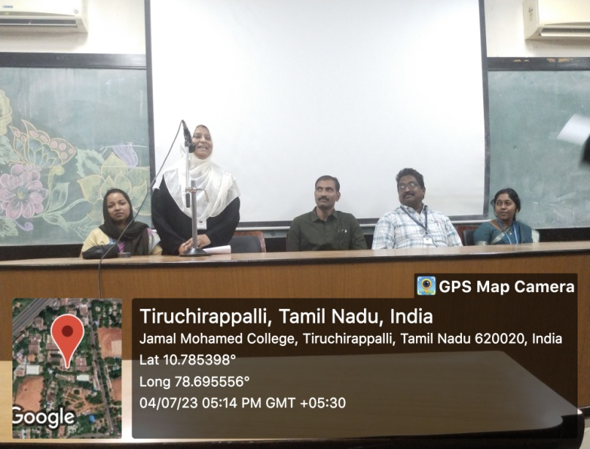
DR. I. JOSEPH ANTONY JERALD, HOD WELCOMED THE GATHERING MS. A. FAMITHA BANU, AVP PRECIDES THE GATHERING

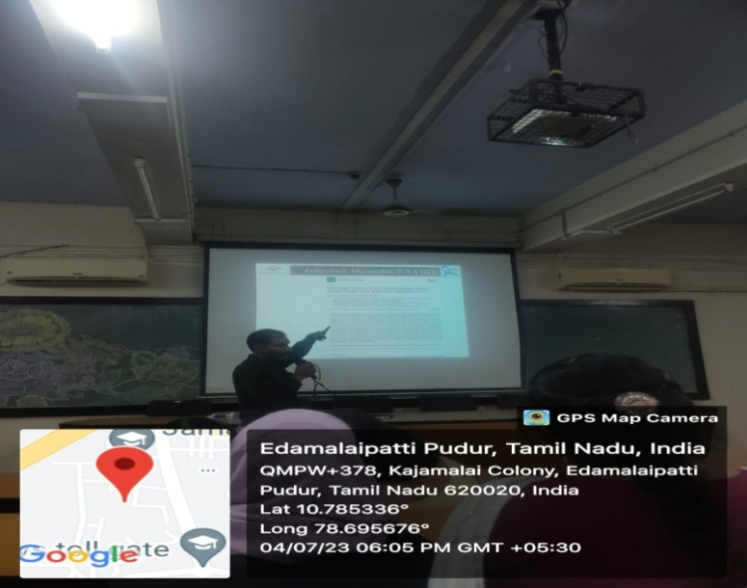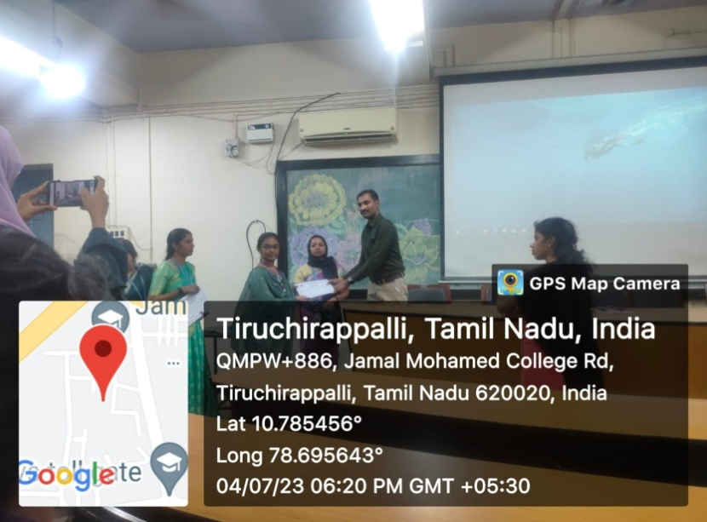

SPECIAL LECTURE BY DR. SURESH MICKYMARAY VAC CERTIFICATE DISTRIBUTED BY CHIEF GUEST

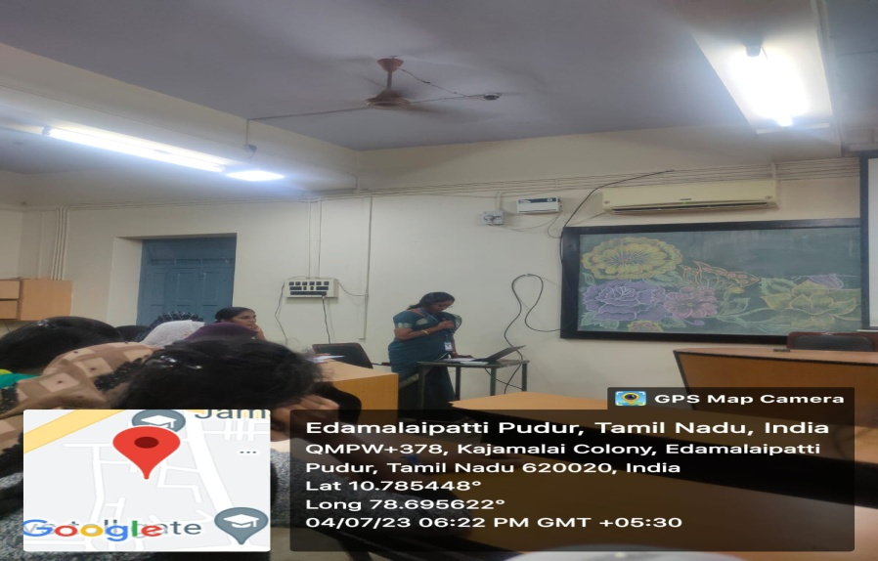
VOTE OF THANKS PROPOSED BY DR.P. DHANALAKSHMI

